Project Design Phase-II

Data Flow Diagram & User Stories

|  |  |
| --- | --- |
| Date | 03 October 2022 |
| Team ID | PNT2022TMID42593 |
| Project Name | Estimate the crop yield using data analytics |
| Maximum Marks | 4 Marks |

# Data Flow Diagrams:

A Data Flow Diagram (DFD) is a traditional visual representation of the information flows within a system. A neat and clear DFD can depict the right amount of the system requirement graphically. It shows how data enters and leaves the system, what changes the information, and where data is stored.

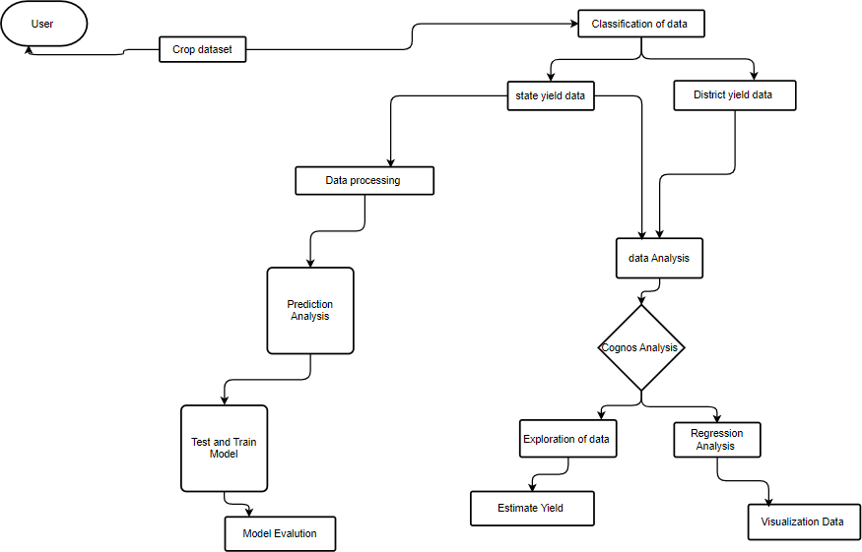

# User Stories

|  |  |  |  |  |  |  |
| --- | --- | --- | --- | --- | --- | --- |
| **User Type** | **Functional Requirement (Epic)** | **User Story Number** | **User Story / Task** | **Acceptance criteria** | **Priority** | **Release** |
| Customer (Mobile user) | Registration | USN-1 | As a user, I can register for the application by  entering my email, password, and confirming my password. | I can access my account / dashboard | High | Sprint-1 |

|  |  |  |  |  |  |  |
| --- | --- | --- | --- | --- | --- | --- |
| **User Type** | **Functional Requirement (Epic)** | **User Story Number** | **User Story / Task** | **Acceptance criteria** | **Priority** | **Release** |
|  |  | USN-2 | As a user, I will receive confirmation email once I have registered for the application | I can receive confirmation email & click confirm | High | Sprint-1 |
|  |  | USN-3 | As a user, I can register for the application through Facebook | I can register & access the  dashboard with Facebook Login | Low | Sprint-2 |
|  |  | USN-4 | As a user, I can register for the application through Gmail |  | Medium | Sprint-1 |
|  | Login | USN-5 | As a user, I can log into the application by entering email & password |  | High | Sprint-1 |
|  | Dashboard | USN-6 | I can access the dashboard of mine. |  | Medium | Sprint 2 |
| Customer (Web user) | Activity | USN-7 | I can register for the application through any web browser. | I can get an notification from the browser | Low | Sprint 1 |
| Customer Care Executive | Access resources | USN-8 | I can use my credentials For accessing my resources. | Other than me, there is less chance to access my resources. | High | Sprint 1 |
| Administrator | Satellite visioning | USN-9 | As, a user I can vision the geographic area |  | Medium | Sprint 2 |
| Customer tools | Tools | USN-10 | I can perform analysis by tools(cognos and with ML) | I have an ease of accessing tools. | High | Sprint 1 |
|  |  |  |  |  |  |  |
|  |  |  |  |  |  |  |